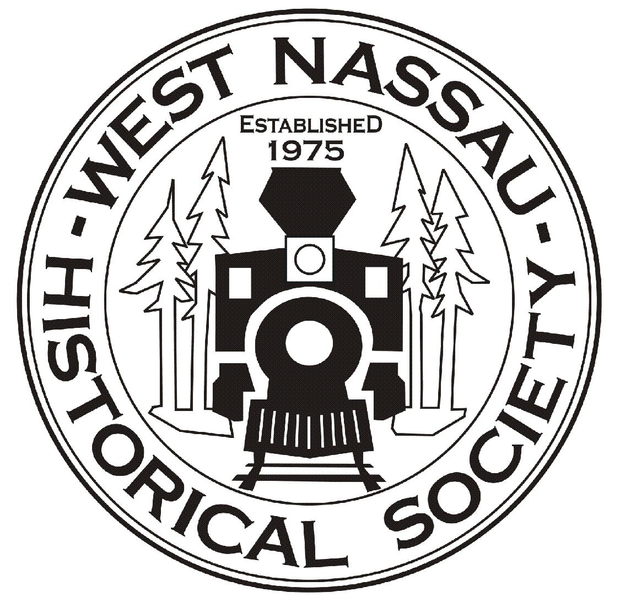
2024 HOBO DAY
FESTIVAL, TRACTORS, AND
VETERANS APPRECIATION
SATURDAY, November 16
TRATOR SHOW 10A-2P
Awards Ceremony at 2 pm
At the Historic Callahan Train Depot
And on the historic Pavilion railroad bed
45383 Dixie Ave, Callahan, FLA
FESTIVAL 9A-4P
Kids Area – Live Entertainment
FOR MORE INFO, CALL 904-879-3406
(See form on back for more show info)
2024 HOBOS, TRACTORS, HEROES
TRACTOR/FARM EQUIP/MACHINES
ENTRY FORM
Name________________________________________
Address______________________________________
City/State/Zip_________________________________
Email________________________________________
Phone________________________________________
Tractor______Farm Equip_____antique machine______Other____
Description______________________________________________
No entry fee this year. (Donations accepted)
Plaques awarded in various categories.
You may bring any farm items or parts to sale.
This Tractor and Antique Equipment Show is presented by the
West Nassau Historical Society as a fundraiser for
the all-volunteer local nonprofit West Nassau Historical Society.
The Historical Society’s mission is to highlight and promote our county’s rich and diverse history and culture and to maintain the historic 1881 Callahan Train Depot located on 45383 Dixie Ave. For more info pr to donate or join our group,
visit www.wnhsfl.org

